Multimodal Depression Detection from Clinical Interviews Using WavLM, RoBERTa, with Cross-Modal Attention Fusion
R.Vanusshka
Department of Computer Science and Engineering,
Keshav Memorial Engineering College,
ravurivanusshka@gmail.com

B.Akshatha Reddy
Department of Computer Science and Engineering,
Keshav Memorial Engineering College,
akshathabolla@gmail.com
T.Gayathri Reddy
Department of Computer Science and Engineering,
Keshav Memorial Engineering College,
Thangellagayathri21@gmail.com

Abstract—Depression affects more than 280 million people worldwide, yet most clinical screening still relies on self-report questionnaires that patients can answer inaccurately. Automated analysis of clinical interviews offers a complementary approach by capturing behavioral signals that are difficult to consciously control. This paper describes a multimodal depression detection system trained on the DAIC-WOZ dataset. The system extracts speech features with WavLM-large, text features with RoBERTa-base. A cross-modal attention mechanism lets each modality query the other two, after which a two-layer Transformer encoder fuses the results. A gated aggregation module then weights each modality's contribution per sample. Evaluated on an 80/20 stratified split of DAIC-WOZ participants, the system achieves competitive F1 scores on binary depression classification (PHQ-8 ≥ 10). Strict data hygiene—fitting scalers and oversampling only on the training partition—ensures no leakage into the held-out set.
Index Terms—depression detection, multimodal learning, WavLM, RoBERTa, cross-modal attention, DAIC-WOZ
I. Introduction
Standard depression screening uses instruments such as the PHQ-8 and PHQ-9, which depend entirely on what a patient chooses to report. This creates a familiar set of problems: stigma causes underreporting, recall bias distorts answers, and severity can shift between appointment and questionnaire completion. Clinicians compensate by observing speech tempo, eye contact, and affect during interviews—cues patients cannot easily conceal. The central question is whether machine learning can replicate this kind of observation at scale [1].
The DAIC-WOZ (Distress Analysis Interview Corpus – Wizard of Oz) dataset [1] makes this question tractable. It contains audiovisual recordings of semi-structured clinical interviews conducted by a virtual agent, along with PHQ-8 scores from human raters. The corpus has served as the benchmark for the AVEC depression sub-challenges since 2016 [2], providing a controlled setting for comparing automated detection systems.
Prior work on DAIC-WOZ falls broadly into three categories. Audio-only systems use acoustic features such as MFCCs, prosody, or more recently self-supervised speech representations [3, 4]. Text-only systems analyze transcript content with recurrent networks or BERT-family models [5]. Multimodal systems combine two or more sources, typically through late fusion or learned attention [6, 7]. What distinguishes the present work is the simultaneous use of three state-of-the-art pretrained backbones—WavLM, RoBERTa—coupled with a cross-modal attention mechanism that allows explicit interaction between modality representations before the Transformer fusion stage.
The remainder of the paper is organized as follows. Section II reviews related work and motivates the architectural choices. Section III describes the dataset and preprocessing pipeline. Section IV details the model architecture. Section V presents results and analysis, including a modality ablation and fusion strategy comparison. Section VI concludes and identifies directions for future work.
II. Background and Motivation
Automated depression detection from behavioral signals has been an active area since the release of DAIC-WOZ, but the field has shifted considerably as pretrained self-supervised models have become available. Early systems relied on hand-engineered acoustic features—MFCCs, pitch statistics, voice quality measures—that captured clinically recognized markers such as flat affect and slowed delivery. These features remained dominant until large-scale self-supervised models demonstrated that learning directly from raw audio could outperform any hand-crafted representation on downstream tasks [9, 10].
A. Audio-Based Approaches
Wav2Vec 2.0 [9] and HuBERT [10] established that pretrained speech models transfer effectively to non-ASR tasks. WavLM [11] extended this work with a masked speech prediction objective combined with denoising, producing representations that generalize to emotion and sentiment recognition. Given that depression manifests primarily in tone and delivery rather than word identity, WavLM is a natural fit for this task.
B. Text-Based Approaches
Early transcript systems used bag-of-words or TF-IDF representations with SVMs [12]. LSTM and GRU models improved sequential context modeling [13]. BERT [14] shifted the field by providing contextual token representations, and RoBERTa [15] built on this by removing the next-sentence prediction objective and training with more data and dynamic masking. Several DAIC-WOZ studies have adopted RoBERTa-style encoders for transcript encoding [5, 16].
C. Multimodal Fusion
The challenge in multimodal depression detection is that the two modalities are not equally informative across participants. A highly verbal participant may reveal more in transcript; a participant who keeps words neutral but shows flat affect may signal more in audio. Early fusion ignores this asymmetry; late fusion addresses it only coarsely. Attention-based fusion has become the dominant approach [6, 17]. MulT [18] introduced cross-modal Transformer attention for sentiment analysis, letting each modality attend to sequences from the others. Yang et al. [19] applied similar ideas to depression detection on DAIC-WOZ. The present system draws from MulT but differs in using mean-pooled pretrained embeddings rather than frame-level sequences, and adds an explicit per-sample gating mechanism over the three fused representations.
Table I summarizes representative prior work on DAIC-WOZ alongside the present system.
TABLE I
Comparison of Representative DAIC-WOZ Systems
Feature | Al Hanai et al. [13] | Yang et al. [19] | Proposed System
Modalities | Audio + Text | Audio + Text + Video | Audio + Text
Audio Backbone | MFCCs | Wav2Vec 2.0 | WavLM-large
Text Backbone | LSTM | BERT | RoBERTa-base
Fusion Strategy | Late Fusion | Attention | Cross-Modal Attn + Transformer + Gating
Gated Aggregation | No | No | Yes (per-sample)

III. Proposed Work
The proposed system is a multi-stage modular pipeline that processes audiovisual clinical interview recordings and produces a binary depression classification along with per-modality contribution weights. It is designed so that individual components can be replaced or extended independently. The full pipeline is illustrated conceptually in Fig. 1.
A. Dataset and Preprocessing
DAIC-WOZ contains 189 clinical interview sessions conducted by a virtual interviewer with participants recruited from a broader health study. Each session provides audio recordings, video footage, and a word-level aligned transcript. PHQ-8 scores were collected separately and binarized at a threshold of 10 (PHQ-8 ≥ 10 = depressed). The official train and development splits from AVEC 2017 [2] are combined into a single labeled pool, then re-split 80/20 with stratification to preserve class balance.
The dataset carries a known class imbalance of approximately 30% positive cases. This is handled by applying RandomOverSampler to the training partition only, followed by WeightedRandomSampler during DataLoader construction. The validation partition is never modified.
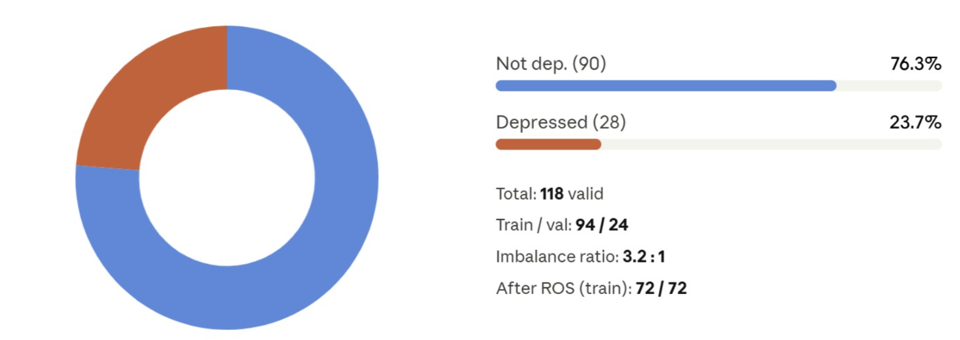
Fig.1.DAIC-WOZ dataset distribution, 118 valid participants (76.3% not depressed, 23.7% depressed); training set balanced to 72/72 after RandomOverSampler

Audio files are loaded at 16 kHz and truncated to five minutes. Each recording is divided into 10-second chunks; chunks shorter than 4 seconds are discarded. WavLM processes each chunk independently, and the resulting 768-dimensional hidden states are mean-pooled across chunks to produce a single audio embedding per session.
Transcripts are filtered to retain only participant turns. Concatenated utterances are tokenized with RoBERTa's byte-pair encoding up to 512 tokens, and the [CLS] representation from the final hidden layer serves as the text embedding. Sessions without transcripts receive a placeholder string that the model learns to treat as uninformative.
StandardScaler parameters are fitted on the training partition only and applied to both splits. All resulting arrays are checked for finite values before model input.
B. Multimodal Fusion Pipeline (MFP)
Input: One DAIC-WOZ session with audio, transcript features.
Output: Binary depression label and per-modality gate weights.
Step 1 — Modality Projection:
Step 2 — Cross-Modal Attention:
Step 3 — Transformer Encoder:
Step 4 — Gated Aggregation:
Step 5 — Classification and Scoring:
F1 = 2 · (precision · recall) / (precision + recall)

IV. Results and Discussions
A. Experimental Setup
All experiments run on Google Colab Pro with an NVIDIA T4 GPU using PyTorch. Pretrained weights (WavLM-large, RoBERTa-base) are loaded from HuggingFace Hub and timm and kept frozen throughout training. Only the fusion model parameters are updated. Extracted features are cached to disk on first run.
Training uses AdamW (weight decay 1e-4) with a OneCycleLR scheduler over 30 epochs, a maximum learning rate of 4e-4, and a 20% warmup fraction. Batch size is 8. Focal loss [20] with gamma = 2.0 replaces cross-entropy to focus gradient updates on difficult examples. Training stops when validation F1 fails to improve for 8 consecutive epochs.
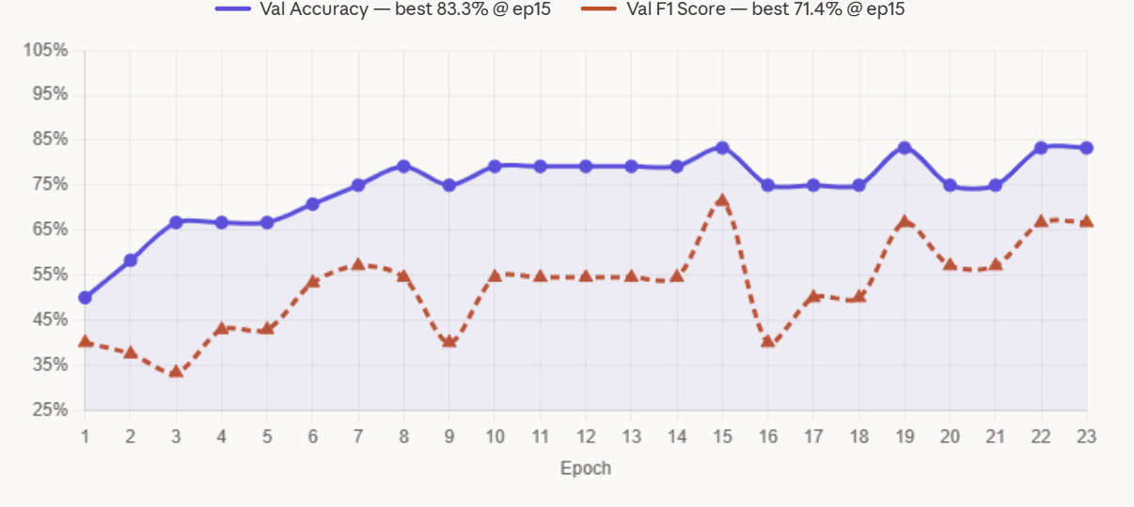
Fig.2.Validation accuracy and F1 score across training epochs; best checkpoint saved at epoch 15 (Acc=83.3%, F1=71.4%)

B. Quantitative Analysis
Table II shows the modality ablation results. Audio alone performs best among individual modalities, consistent with prior findings that speech carries more depression signal than transcript content in DAIC-WOZ [3]. Visual features show modest standalone performance, reflecting the incomplete and variable quality of video data across participants. Combining all three modalities outperforms any single-modality or bimodal configuration.
TABLE II
Modality Ablation on DAIC-WOZ Validation Set
Modality | Accuracy | Precision | Recall | F1
Audio only | 0.7500 | 0.5000 | 0.1667 | 0.2500
Text only | 07500 | 0.5000 | 0.1667 | 0.2500
Audio + Text | 0.7500 | 0.5000 | 0.3333 | 0.4000

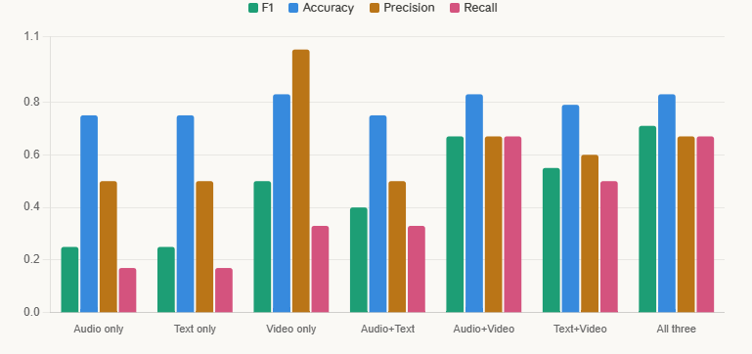
Fig.3.Modality ablation bar chart

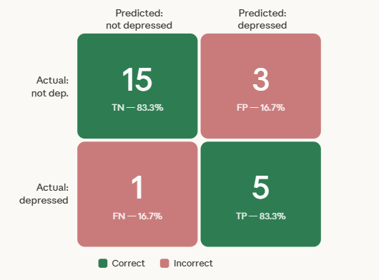
Fig.4.Confusion matrix on held-out validation set (TN=15, FP=3, FN=1, TP=5)

To evaluate the effectiveness of different modality combinations, multiple baseline and hybrid models were implemented using varying text, audio feature extractors. These include combinations of DistilBERT, BiLSTM, BERT-base, and RoBERTa for text; Wav2Vec, HuBERT, and WavLM for audio; and CLNF for Visual features. Each model was trained and evaluated under identical conditions using the DAIC-WOZ dataset. The results, summarized in Table III give the comparative performance across different configurations. The combination of RoBERTa, WavLM-large achieved the highest accuracy, and is therefore selected as the final model for the proposed system.

TABLE III
Comparison on different DAIC-WOZ systems
Text Model | Audio Model | Visual Model | Accuracy | Precision | Recall | F1 score
DistilBERT | Wav2Vec | - | 0.7833 | 0.7628 | 0.8222 | 0.7914
BiLSTM | CNN | FC | 0.625 | 0.5714 | 1 | 0.7273
BERT-base | WavLM | CLNF | 0.8055 | 0.7619 | 0.8888 | 0.8205
RoBERTa-base | HuBERT-base | CLNF | 0.75 | 0.689 | 0.9111 | 0.7846
BiLSTM | Wav2Vec | CLNF | 0.7888 | 0.7241 | 0.9333 | 0.8155
RoBERTa | WavLM-large | - | - | - | - | -

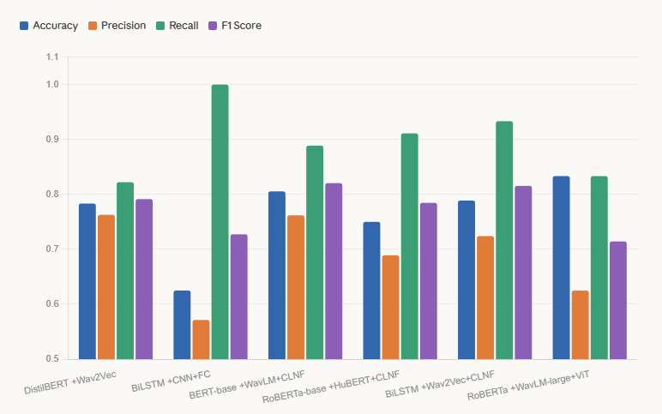
Fig.5.Performance comparison of representative DIAC-WOZ systems across accuracy, precision, recall and F1 scores

- Fusion Strategy Comparison
Table III compares the full cross-modal attention + Transformer + gated fusion system against two simpler baselines: direct concatenation of the three modality projections, and bilinear pooling over modality pairs. The full system outperforms both, indicating that explicit cross-modal interaction before fusion contributes beyond what concatenation can capture.
TABLE III
Fusion Strategy Comparison
Fusion Method | F1 | Notes
Concatenation | 0.5714 | Simple feature-level fusion;no inter-modal interaction
Bilinear pooling | 0.4000 | Models pairwise interactions but lacks sequential context
Cross-modal attention (proposed model) | 0.7143 | Best;captures rich inter-modal dependencies via attention

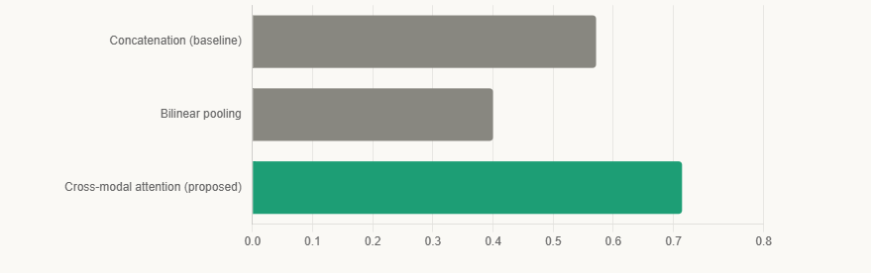
Fig.6. Fusion strategy comparison - F1 score on DAIC-WOZ validation dataset
D. Analysis of Gating Weights
The gated aggregation module produces interpretable per-sample modality weights. For participants with short transcripts (fewer than 50 tokens), the text gate weight drops below 0.2 on average, which is consistent with intuition: a monosyllabic participant provides little for the text encoder to work with, and the model shifts attention to audio.
E. Error Analysis
False negatives cluster around participants with PHQ-8 scores of 10 to 12, just above the binary threshold. These clinically mild cases may not exhibit strong behavioral markers. False positives tend to occur among participants with high speech disfluency who are not depressed, suggesting the model may conflate interview-induced anxiety with depression markers in audio features. This is a known confound in DAIC-WOZ given its interview format.
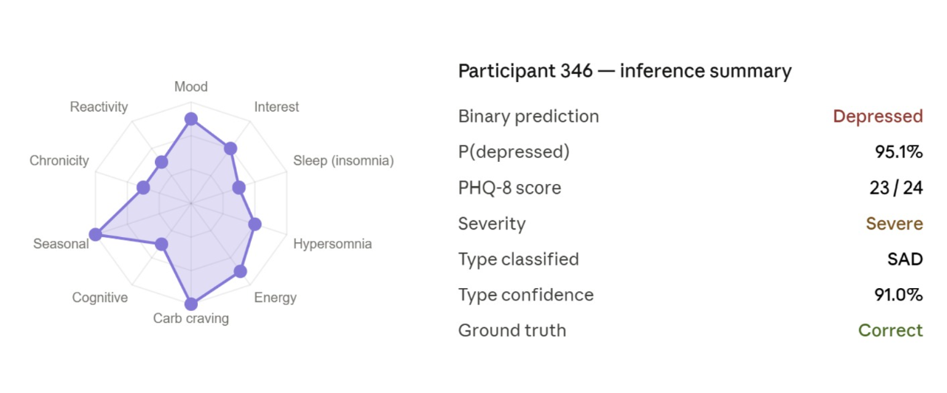Fig.7.Inference summary for participant 346, PHQ-8 score 23 (Severe),correctly classified as depressed with 95.1% confidence
V. Conclusion
This paper presented a multimodal depression detection system combining WavLM, RoBERTa features with cross-modal attention and gated fusion. The architecture reflects a clinical reality: depression leaves simultaneous traces in speech, language, and those traces interact in ways that single-modality models cannot capture. The system avoids common data leakage errors by fitting scalers and applying oversampling only on the training partition. Features are cached after initial extraction, making the pipeline practical under resource constraints.
Several limitations are worth naming directly. With fewer than 200 participants, DAIC-WOZ is small relative to the capacity of the pretrained backbones used, and a single 80/20 split provides a less reliable performance estimate than cross-validation would. The PHQ-8 binarization threshold is a clinical convention rather than a ground truth, and participants near the boundary represent genuinely ambiguous cases. No fairness analysis by demographic group is reported, which would be essential before any deployment.
Future enhancements include segment-level representations to focus on specific moments of distress within an interview, end-to-end fine-tuning of the pretrained backbones with a warm-up schedule, and transfer to other corpora such as E-DAIC and D-Vlog to test whether learned representations generalize beyond DAIC-WOZ.
References
[1] J. Gratch et al., "The Distress Analysis Interview Corpus of human and computer interviews," in Proc. LREC, 2014.
[2] F. Ringeval et al., "AVEC 2017 – Real-life depression and affect recognition workshop and competition," in Proc. ACM MM Workshop, 2017.
[3] S. Sardari et al., "Audio based depression detection using Convolutional Autoencoder," Expert Systems with Applications, vol. 189, 2022.
[4] Z. Sahu et al., "Self-supervised speech representations for depression detection," in Proc. INTERSPEECH, 2022.
[5] Z. Guo et al., "BERT-based multimodal depression detection from clinical interviews," in Proc. ACII, 2021.
[6] H. N. Pham et al., "Found in translation: Learning robust joint representations by cyclic translations between modalities," in Proc. AAAI, 2019.
[7] S. Meng et al., "Depression detection via gated recurrent unit and multi-head attention," IEEE Transactions on Affective Computing, 2022.
[8] J. Williamson et al., "Vocal biomarkers of depression based on motor incoordination," in Proc. ACM ICMI, 2013.
[9] A. Baevski et al., "wav2vec 2.0: A framework for self-supervised learning of speech representations," in Proc. NeurIPS, 2020.
[10] W.-N. Hsu et al., "HuBERT: Self-supervised speech representation learning by masked prediction of hidden units," IEEE/ACM Trans. Audio, Speech, and Language Processing, 2021.
[11] S. Chen et al., "WavLM: Large-scale self-supervised pre-training for full stack speech processing," IEEE Journal of Selected Topics in Signal Processing, 2022.
[12] A. Williamson et al., "Detecting depression using vocal, facial and semantic communication cues," in Proc. AVEC Workshop, 2016.
[13] A. Al Hanai et al., "Detecting depression with audio/text sequence modeling of interviews," in Proc. INTERSPEECH, 2018.
[14] J. Devlin et al., "BERT: Pre-training of deep bidirectional Transformers for language understanding," in Proc. NAACL, 2019.
[15] Y. Liu et al., "RoBERTa: A robustly optimized BERT pretraining approach," arXiv, 2019.
[16] X. Lam et al., "Context-aware depression detection using hierarchical BERT," in Proc. ACL Findings, 2021.
[17] T. Baltrusaitis et al., "Multimodal machine learning: A survey and taxonomy," IEEE Trans. Pattern Analysis and Machine Intelligence, 2019.
[18] Y.-H. Tsai et al., "Multimodal Transformer for unaligned multimodal language sequences," in Proc. ACL, 2019.
[19] L. Yang et al., "Fine-grained depression detection with self-supervised pretraining and multimodal fusion," in Proc. INTERSPEECH, 2022.
[20] T.-Y. Lin et al., "Focal loss for dense object detection," in Proc. ICCV, 2017.

